 DHOLE PATIL COLLEGE OF ENGINEERING
Engineering Graphics
Assignment on Orthographics Projection
Q.No | Question | Need to Draw | CO | BT LEVEL
1 | 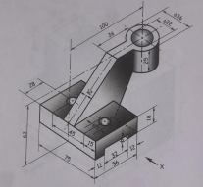 | - Sectional FV in direction X,  - TV  - LHSV | CO5 | 3APPLY
2 | 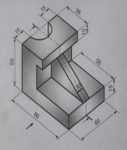 | - Sectional FV in direction of arrow  - TV  - RHSV | CO5 | 3 APPLY
3 | 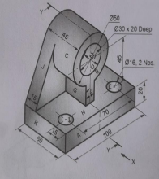 | - FV in direction of arrow,  - TV  - sectional LHSV | CO5 | 3APPLY
4 | 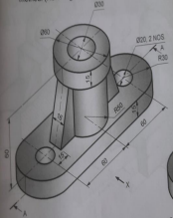 | - Sectional FV in the direction of arrow  - TV  - LHSV | CO5 | 3APPLY
5 | 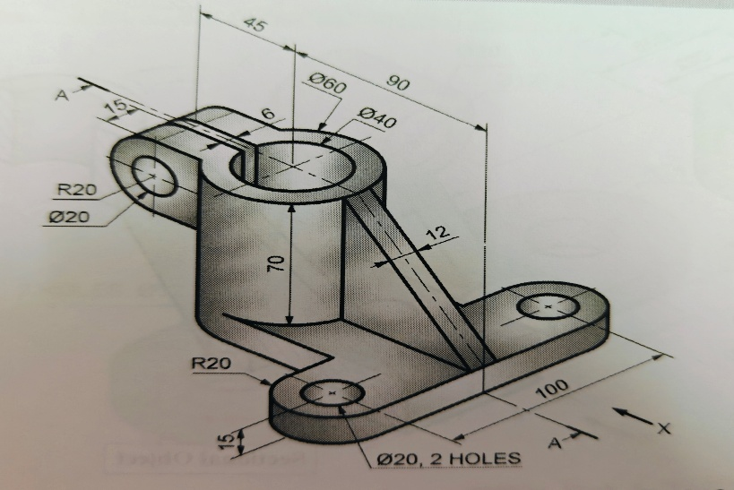 | - FV in direction of X  - TV  - Sectional LHSV | CO5 | 3APPLY
6 | 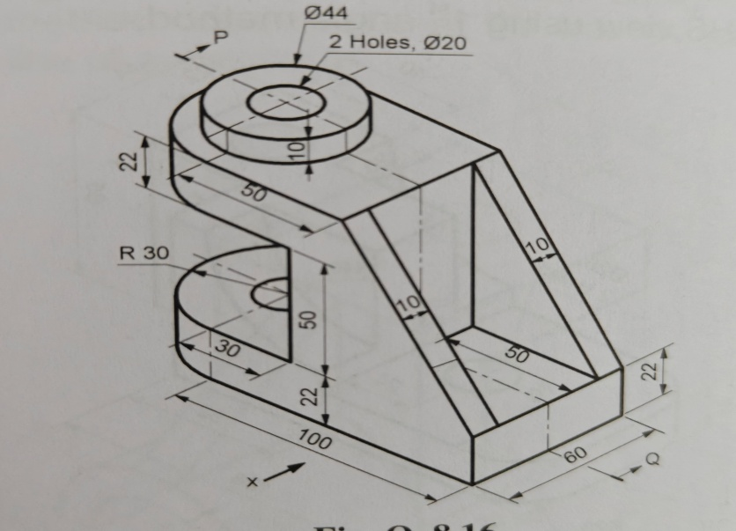 | - Sectional FV in X  - TV  - RHSV | CO5 | 3 Apply

